Hello All,

As part of **#90DaysofDevops** I am happy to share my **#Day2** learnings here.

**What makes Linux so popular among DevOps?**

Linux makes automation easy; hence, it has become an integral part of DevOps professionals. The best advice anybody can get while starting their journey in DevOps is to learn and understand the basics of Linux thoroughly. This makes the DevOps career path easy in the future.

**What is Linux?**

Linux is an operating system that is high performing and opensource.

With Linux, users get great flexibility in customizing the system as per their desire and requirements.

**Why Linux?**

Linux provides a powerful command-line interface that helps system administrators to write shell scripts and automate routine and various repetitive tasks.

The uptime and availability for Linux servers are very high.

Linux has the highest number of servers running on the Internet.

Linux distribution is an operating system that is made up of a collection of software based on Linux kernel or you can say distribution contains the Linux kernel and supporting libraries and software.

Around 600 + Linux Distributions are available and some of the popular Linux distributions are:

RedHat Linux, OpenSuse, Ubuntu, Debian, Linux Mint, CentOS, Fedora.

**Architecture of Linux**

Linux architecture has the following components:

1. **Kernel:**Kernel is the core of the Linux based operating system. It virtualizes the common hardware resources of the computer to provide each process with its virtual resources.
2. **Shell:**It is an interface to the kernel which hides the complexity of the kernel’s functions from the users. It takes commands from the user and executes the kernel’s functions.
3. **Hardware Layer:**This layer consists all peripheral devices like RAM/ HDD/ CPU etc, controls and allocates memory and send instructions.
4. **System Utility or Application:**It provides the functionalities of an operating system to the user.

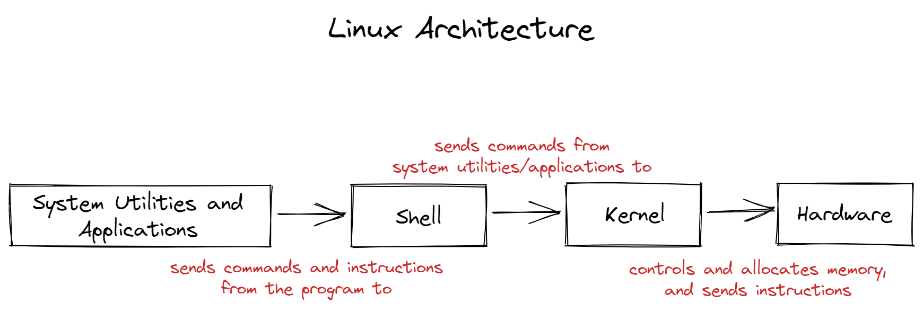

Basic Commands Explored:  
1. Check your present working directory:  
=>  pwd  
  This command displays the current directory you're in.  
  
2. List all the files or directories, including hidden ones:  
  => ls -la  
  With this, you can view all files and directories, even the hidden ones (those starting with a dot).  
  
3. Create a nested directory:  
  => mkdir -p A/B/C/D/E  
  In one command, I was able to create a nested directory structure. 'mkdir' stands for "make directory", and the '-p' flag allows for the creation of parent directories as needed.

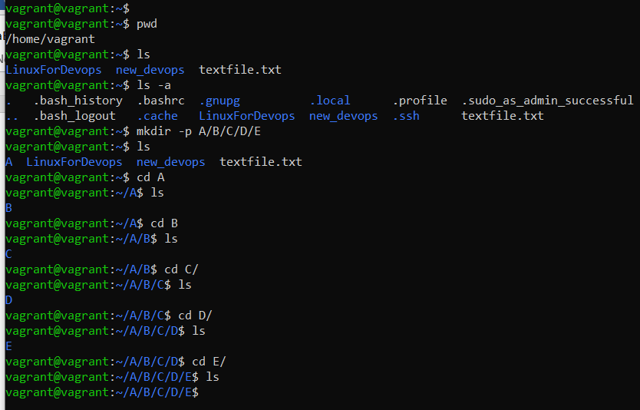

**#Day2** **#90DaysofDevops** **#Trainwithshubham** **#DevOps** **#Linux** **#happyLearner**